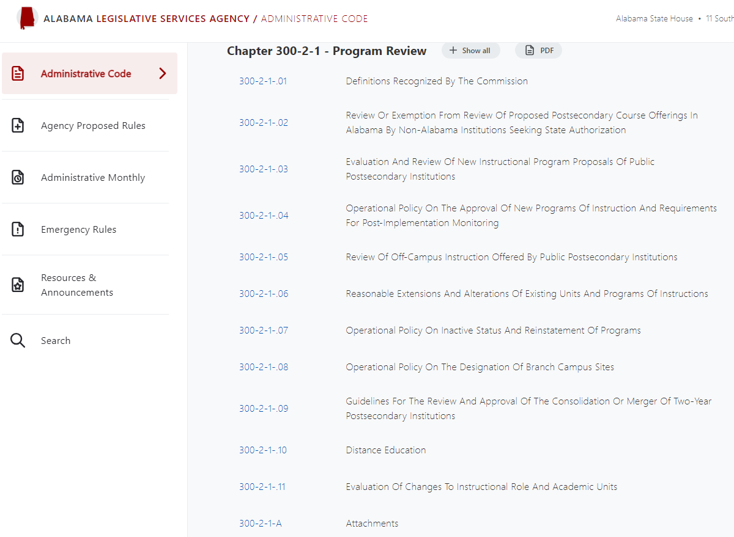

<https://admincode.legislature.state.al.us/administrative-code/300-2-1-.05>

<https://admincode.legislature.state.al.us/administrative-code/300-2-1-A>

# 300-2-1-.05 Review Of Off-Campus Instruction Offered By Public Postsecondary Institutions and Determination of Service Areas.

1. Purpose: The purpose of reviewing and approving or disapproving off-campus offerings of public postsecondary institutions is to ensure that such offerings meet the criteria and standards established by the Alabama Commission on Higher Education and to ensure that educational needs across the state are being met, while maintaining the integrity of institutional service areas.
2. Commission Responsibility**:** It is the responsibility of the Alabama Commission on Higher Education to monitor off-campus instructional offerings within the state of Alabama and establish policies and procedures for reviewing new or existing off-campus sites of public postsecondary institutions in Alabama, except for exempt sites delineated by the Commission's statute. (~~See the definition for Exempt Sites listed below at 4.)~~
3. Definitions**:** For purposes of this rule, the following definitions apply:
   1. Off-Campus Site: The specific location where one or more courses are offered for academic credit geographically distant from the sponsoring institution's main campus. An off-campus site will be designated as exempt or non-exempt:
4. Exempt Sites: The following off-campus sites are exempt from Commission approval and require prior notification only.
5. Sites at which the Fall 1978 registrations exceeded 500 class enrollments (exempted by statue, see Code of Ala. 1975, §16-5-8[d]).
6. University sites which were operated prior to 1960 (exempted by statue, see Code of Ala. 1975, §16-5-8[d]).
7. Sites located on military reservations (exempted by statue, see Code of Ala. 1975, §16-5-8[d]).
8. Business and industry sites where only their employees are enrolled in the off-campus courses (exempted by statue, see Code of Ala. 1975, §16-5-8[d]).
9. Off-campus prison sites where courses are taught exclusively for inmates and prison employees (exempted by Commission decision on March 2, 2007).
10. ~~Courses offered on an individual study basis~~.
11. ~~Study abroad.~~
12. High school sites where courses are taught exclusively to high school students enrolled in early admission, accelerated, or dual enrollment/dual credit programs (exempted by Commission decision on March 2, 2007).
13. Two-year college sites located within their respective ~~State Board of Education approved~~ service areas (exempted by Commission decision on March 2, 2007).
14. University sites located within their respective service areas (exempted by Commission decision on March 2, 2007).
15. Non-Exempt Sites: Any off-campus site that does not fit within one of the exemptions enumerated above shall be considered non-exempt and will ~~be subject to the regular review process described below~~ require Commission approval before instruction can be offered at the site.

* 1. ~~Off-Campus Facility: The actual physical plant in which instruction is conducted at an off-campus site.~~

~~Branch: A degree-granting division of an institution located in a geographical setting separate from the sponsoring institution's main campus or central administration and authorized for a stated purpose in relation to the sponsoring institution and the area served. The branch offers all requirements for completing degree programs in two or more fields of study as classified by the CIP taxonomy at the 6-digit level. A branch provides the necessary administrative services, student services, financial resources, library, and physical facilities to provide adequate support for degree programs offered.~~

Branch Campus: A special form of off-campus instructional site that is geographically apart from an institution’s main campus, where instruction is delivered, and is independent of the main campus of an institution. An off-campus instructional site is independent of the main campus if it is permanent; offers courses in educational programs leading to a degree, diploma, certificate, or other for-credit credential; has its own faculty and administrative or supervisory organization; and has its own budgetary and hiring authority. See also §300-2-1-08 (“Operational Policy on the Designation of Branch Campus Sites”).

1. ~~Branch Campus: The physical boundaries of the location of an institution branch.~~
2. Off-Campus Instruction: A for-credit course or program taken by a student or students at a location other than a Commission-recognized main or branch campus of the sponsoring institution. The Commission’s policy on off-campus instruction applies to traditional instructional settings, i.e., face-to-face classroom instruction that occurs at a location away from the Commission-recognized main or branch campus of the institution. ~~(Adapted from a Georgia Board of Regents definition; approved by the Commission on March 2, 2007.)~~
3. Off-Campus Course: A course provided to any group of students for academic credit at a particular off-campus site in an organized classroom setting.
4. Off-Campus Program: A program of instruction ~~offered in its entirety~~ for which 50% or more of the instruction is delivered at an off-campus site. ~~A program of instruction is defined by the Commission as an organized set of courses and related activities for which, upon satisfactory completion, some degree, diploma or certificate is awarded.~~
5. Service Area~~s~~: (~~See attached service area tables.)~~ The geographical area within the state of Alabama where an institution is recognized as a primary provider of for-credit postsecondary instruction and where new off-campus sites are considered exempt from ACHE Commission approval.
6. Scope: This rule shall apply only to off-campus sites located ~~within the service area of one or more public postsecondary institutions~~ within the state of Alabama. This rule does not apply to off-campus sites that are located out of state, nor does it apply to distance education offerings, non-credit offerings, or courses offered on an individual study basis.
7. Establishment of a New Off-Campus Site within an Institution’s Service Area:
   1. Prior Notification Required: An institution seeking to offer instruction at an off-campus site within its recognized service area must notify the Commission prior to delivering instruction at the proposed site.
   2. Documentation Required for New Off-Campus Site: Institutions must submit the following documentation to the Commission as part of their notification for a new off-campus site:
8. Course List: A list of courses from which each term’s schedule will be developed will be submitted with each new site proposal or notification. If the list includes upper-division or graduate-level courses, the institution shall include information about which academic program the courses apply to and the percentage of the program to be delivered at the site. An institution seeking to deliver more than 50% of program coursework at the proposed site may be required to seek approval from the Commission.
9. Summary of Funding of Off-Campus Instruction: Off-campus instruction should be self-supporting, i.e., costs should be covered by tuition, fees, and extramural support. If an institution plans to reallocate its own funds to support instruction at an off-campus site (such as for new equipment or lease of the facility), a business plan must accompany the site notification.
10. Written Consent Not Required: All universities which are located in the same county or which share service areas may offer courses within the shared area, but they should work together and in conjunction with the Commission to avoid the unnecessary duplication of course offerings.
11. Establishment of a New Exempt Off-Campus Site outside an Institution’s Service Area:
    1. Prior Notification Required: An institution seeking to offer instruction at an off-campus site located outside its recognized service area must receive Commission approval, unless the site is considered exempt under one or more of the provisions noted above. Prior notification is required for exempt sites.
    2. Documentation Required: Institutions must submit the following documentation to the Commission as part of their notification for a new exempt off-campus site located outside their recognized service area:
12. Course List: A list of courses from which each term’s schedule will be developed will be submitted with each new site proposal or notification. If the list includes upper-division or graduate-level courses, the institution shall include information about which academic program the courses apply to and the percentage of the program to be delivered at the site. An institution seeking to deliver more than 50% of program coursework at the proposed site may be required to seek approval from the Commission.
13. Summary of Funding of Off-Campus Instruction: Off-campus instruction should be self-supporting, i.e., costs should be covered by tuition, fees, and extramural support. If an institution plans to reallocate its own funds to support instruction at an off-campus site (such as for new equipment or lease of the facility), a business plan must accompany the site notification.
14. Written Consent: Since it is desirable in most instances to have the closest qualified institution respond to off-campus credit course need, the Commission requires that institutions seeking to offer instruction at a new site outside their recognized service area obtain written consent from institutions whose service area includes the proposed site in certain circumstances.
    * 1. Written consent is not required when the proposed site falls under one of the exemptions provided for in statute (see above §(3)(a)1 a-d) .
    1. ~~The following stipulations apply to exemptions 4, 5, and 6 above.~~
15. ~~Information items will be provided to the Commission for any new sites, i.e., sites which previously have not been recognized by the Commission either by formal approval or by information item.~~
    * 1. Since there are instances in which two-year colleges and universities are located within overlapping areas, care must be taken to avoid the unnecessary duplication of lower-division courses. For this reason, a university shall not offer lower-division courses in the home county of a two-year institution main campus which offers similar courses without the written consent of the two-year institution, while a two-year institution shall not offer courses in the home county of a university main campus which offers similar courses without the written consent of the university. This stipulation does not apply to situations in which a university and a two-year college are located in the same county. In these situations, each institution may offer courses within the shared area, but they should work together to avoid the unnecessary duplication of course offering.
      2. A university shall not offer courses in the service area of another university which offers similar courses without the written consent of the resident university.
16. ~~All universities which are located in the same county or which share service areas may offer courses within the shared area, but they should work together and in conjunction with the Commission to avoid the unnecessary duplication of course offerings.~~
    * 1. No off-campus site may be located nearer than 25 miles to a main campus of another institution which offers similar courses without the written consent of that institution.
17. ~~It is desirable in most instances to have the closest qualified institution respond to off-campus credit course needs. [Based on a Georgia Board of Regents policy]~~
18. Establishment of a New Non-Exempt Off-Campus Site outside an Institution’s Service Area
    1. ~~Regular Review Process: All sites which are not covered by one or more of the exemption categories above are subject to regular review and approval by the Commission. For these sites, the following regulations apply.~~
19. ~~New off-campus site proposals must be received by the Commission at least eight weeks in advance of the Commission meeting in which they will be considered.~~
20. ~~No off-campus site may be located nearer than 25 miles to a main campus of another institution which offers similar courses without the written consent of that institution.~~
21. ~~Once an off-campus site is approved it does not require approval in subsequent years, but annual reports are required.~~
22. Compliance with Accreditation Guidelines and Criteria: All sites, exempt and non-exempt, must be in full compliance with the Southern Association of Colleges and Schools Commission on Colleges (SACSCOC) guidelines and criteria pertaining to curriculum, faculty, administration, equipment, learning resources and student services. Council on Occupational Education (COE) guidelines will apply to institutions accredited by that agency.
23. Annual Follow-up Report Requirement: Regardless of exemption status, institutions will submit an annual follow-up report for each off-campus site ~~by July 1 each year~~. The Alabama Community College System (ACCS) ~~Department of Postsecondary Education~~ may submit a comprehensive follow-up report for the entire system.

** ADD SECTION modification of off-campus sites—courses, programs, funding, etc. **

1. Discontinuation of Sites: The Commission must be notified if a site is discontinued so that annual reports will not be expected.
2. Limitation on Course Lists: Extensive course lists of upper-division and graduate-level courses that may constitute a program in any discipline will not be accepted. Should an institution desire to offer an extensive course list in a discipline, a proposal for an off-campus program should be submitted for Commission review and approval.
3. Public Review of Off-Campus Course Proposals: All proposals for off-campus courses will be subject to a twenty-day public comment period prior to action or acceptance by the Commission. Proposals must be submitted electronically by the institutions and will be posted to the Commission website for public review and comment. At the end of the twenty-day period, the Commission staff will compile the comments and send them to the applicant institution for response.
4. Compliance Monitoring Authority: The Commission retains the authority to monitor compliance with the guidelines. If infractions are found, they will be referred to the appropriate governing board for corrective action.
5. ~~Funding of Off-Campus Instruction: Off-campus instruction should be self-supporting; i.e. costs should be covered by tuition, fees, and extramural support. The Commission will not include credit hours and enrollment generated by off-campus instruction in its formula calculations in developing institutional budget recommendations.~~
6. Review and Approval of Off-Campus Programs: In addition to all criteria stated for the approval of off-campus courses, the following additional criteria shall apply to the approval of off-campus instructional programs (approved by the Commission on March 2, 2007):

NEEDS SECTION ON SERVICE AREA DETERMINATION/ UPDATES

Language copied from above under definitions:

For the purposes of off-campus instruction, service areas for the two-year colleges are those determined by the Alabama Community College System (ACCS) ~~State Board of Education~~. Service areas for senior institutions are determined by the Commission, using the following considerations:

1. Proximity of the off-campus site to the sponsoring institution
2. Relationship of the off-campus site to the sponsoring institution based on student source reports that are produced using data from the Alabama Statewide Student Database; and
3. The mission of the institution.

What if an institution wants to update its service area? How often can it be done? What if another institution wants to challenge the service area request?

**Author:** William O. Blow

**Statutory Authority:** Code of Ala. 1975, §§16-5-1, et seq. **History**: **New Rule.** Filed on 7/11/95 to replace a repealed rule, "Review of Off-Campus Offerings of Postsecondary Institutions," which had the same rule number. Effective:

August 31, 1995. This rule is based on policy adopted by the Commission on 6/22/79 and revised on 6/19/92 and 2/11/94.

Extensive addition and revision adopted by the Commission on 6/30/95 necessitated the repeal of the former rule and the adoption of the current rule. **Amended:** Filed June 4, 1997; effective July 9, 1997. **Amended:** Filed April 6, 1998; effective

May 11, 1998. **Repealed and New Rule:** Filed December 5, 2000;

effective January 9, 2001. **Amended:** Filed May 7, 2007;

effective June 11, 2007.