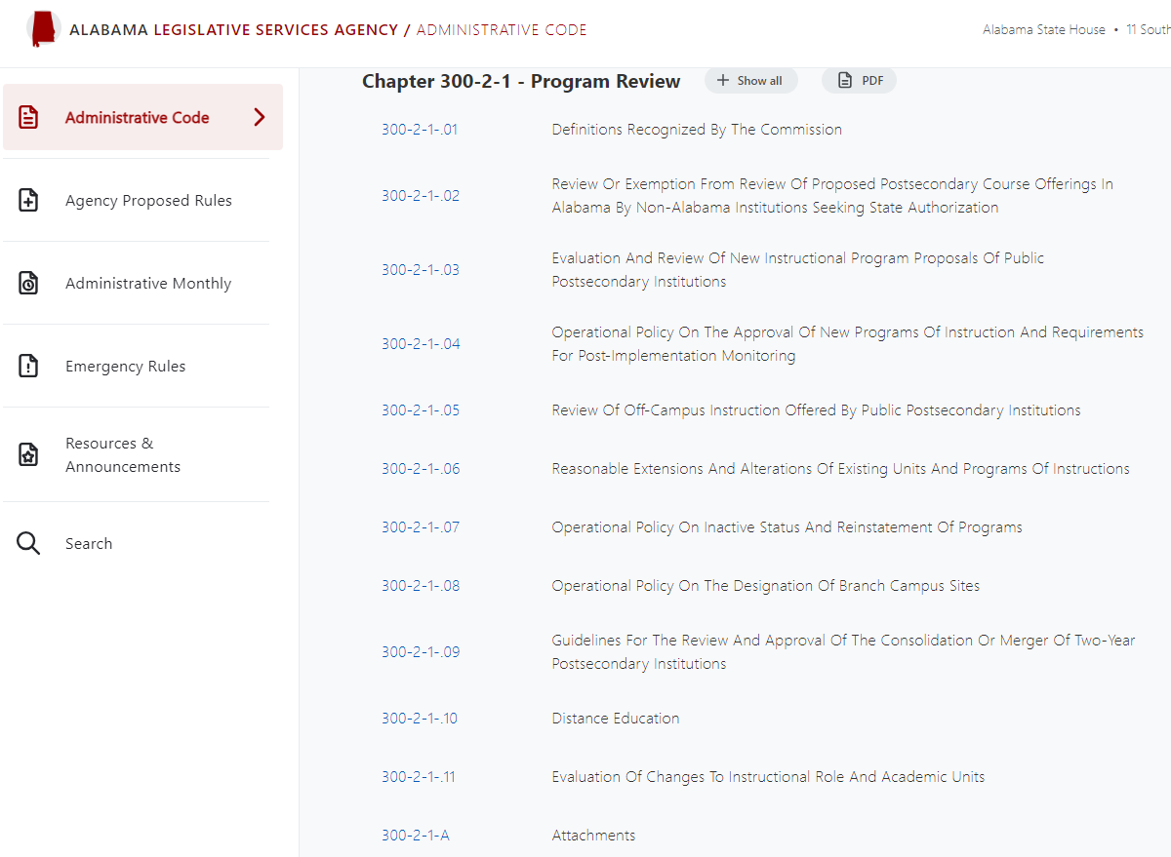

https://admincode.legislature.state.al.us/administrative-code/300-2-1-.05

https://admincode.legislature.state.al.us/administrative-code/300-2-1-A

300-2-1-.05 Review Of Off-Campus Instruction Offered By Public Postsecondary Institutions and Determination of Service Areas.

- Purpose: The purpose of reviewing and approving or disapproving off-campus offerings of public postsecondary institutions is to ensure that such offerings meet the criteria and standards established by the Alabama Commission on Higher Education and to ensure that educational needs across the state are being met, while maintaining the integrity of institutional service areas.

- Commission Responsibility: It is the responsibility of the Alabama Commission on Higher Education to monitor off-campus instructional offerings within the state of Alabama and establish policies and procedures for reviewing new or existing off-campus sites of public postsecondary institutions in Alabama, except for exempt sites delineated by the Commission's statute. (See the definition for Exempt Sites listed below at 4.)

- Definitions: For purposes of this rule, the following definitions apply:

  - Off-Campus Site: The specific location where one or more courses are offered for academic credit geographically distant from the sponsoring institution's main campus.

  - Off-Campus Facility: The actual physical plant in which instruction is conducted at an off-campus site.

[USE SACSCOC definition for “branch campus”]Branch: A degree-granting division of an institution located in a geographical setting separate from the sponsoring institution's main campus or central administration and authorized for a stated purpose in relation to the sponsoring institution and the area served. The branch offers all requirements for completing degree programs in two or more fields of study as classified by the CIP taxonomy at the 6-digit level. A branch provides the necessary administrative services, student services, financial resources, library, and physical facilities to provide adequate support for degree programs offered.
(b) Branch campus: A special form of off-campus instructional site that is geographically apart from an institution’s main campus, where instruction is delivered, and is independent of the main campus of an institution. An off-campus instructional site is independent of the main campus if it is permanent; offers courses in educational programs leading to a degree, diploma, certificate, or other for-credit credential; has its own faculty and administrative or supervisory organization; and has its own budgetary and hiring authority. See also §300-2-1-08 (“Operational Policy on the Designation of Branch Campus Sites”).

- Branch Campus: The physical boundaries of the location of an institution branch.

- Off-Campus Instruction: A for-credit course or program taken by a student or students at a location other than a Commission-recognized main or branch campus of the sponsoring institution. The Commission’s policy on off-campus instruction applies to traditional instructional settings, i.e., face-to-face classroom instruction that occurs at a location away from the Commission-recognized main or branch campus of the institution. (Adapted from a Georgia Board of Regents definition; approved by the Commission on March 2, 2007.)

- Off-Campus Course: A course provided to any group of students for academic credit at a particular off-campus site in an organized classroom setting.

- Off-Campus Program: A program of instruction offered in its entirety for which 50% or more of the instruction is delivered at an off-campus site. A program of instruction is defined by the Commission as an organized set of courses and related activities for which, upon satisfactory completion, some degree, diploma or certificate is awarded.

- Service Areas: (See attached service area tables.) The geographical area within the state of Alabama where an institution is recognized as a primary provider of for-credit postsecondary instruction and where new off-campus sites are considered exempt from ACHE Commission approval.

- Scope: The following sections shall apply only to off-campus sites located within the service area of one or more public postsecondary institutions within the state of Alabama. This does not apply to off-campus sites that are located out of state or to distance education offerings or non-credit offerings at ...

- Establishment of New Off-Campus Sites: Institutions must receive approval from the Commission before delivering for-credit instruction at a new off-campus site, unless the site is considered exempt by statute or by Commission decision. For a new exempt site, institutions must notify the Commission prior to delivering off-campus instruction at that site.

  - Exempt Sites: The following off-campus sites are exempt from Commission approval.

- Statutory Exemptions (Code of Ala.1975, 16-5-8 as amended):

- Sites at which the Fall 1978 registrations exceeded 500 class enrollments.

- University sites which were operated prior to 1960.

- Sites located on military reservations.

- Business and industry sites where only their employees are enrolled in the off-campus courses.

- Additional exemptions approved by the Commission:

- Off-campus prison sites where courses are taught exclusively for inmates and prison employees.

- Courses offered on an individual study basis.

- Study abroad.

- High school sites where courses are taught exclusively to high school students enrolled in early admission, accelerated, or dual enrollment/dual credit programs.

- Two-year college sites located within their respective State Board of Education approved service areas.

- University sites located within their respective service areas.

  - Non-Exempt Sites: Any off-campus site that does not fit within one of the exemptions enumerated above shall be considered non-exempt and will be subject to the regular review process as described below.

  - Determination of Exempt Status: ACHE staff will review materials submitted by an institution to determine whether an off-campus site is considered exempt or non-exempt.

  - Written Consent: Except in the case of statutory exemptions noted above, the Commission shall require written consent of another institution to accompany the notification or proposal for a new off-campus site if any of the following circumstances pertain:

  - The following stipulations apply to exemptions 4, 5, and 6 above.

- Information items will be provided to the Commission for any new sites, i.e., sites which previously have not been recognized by the Commission either by formal approval or by information item.

- Since there are instances in which two-year colleges and universities are located within overlapping areas, care must be taken to avoid the unnecessary duplication of lower-division courses. For this reason, a university shall not offer lower-division courses in the home county of a two-year institution main campus which offers similar courses without the written consent of the two-year institution, while a two-year institution shall not offer courses in the home county of a university main campus which offers similar courses without the written consent of the university. This stipulation does not apply to situations in which a university and a two-year college are located in the same county. In these situations, each institution may offer courses within the shared area, but they should work together to avoid the unnecessary duplication of course offering.

- A university shall not offer courses in the service area of another university which offers similar courses without the written consent of the resident university.

- All universities which are located in the same county or which share service areas may offer courses within the shared area, but they should work together and in conjunction with the Commission to avoid the unnecessary duplication of course offerings.

- No off-campus site may be located nearer than 25 miles to a main campus of another institution which offers similar courses without the written consent of that institution.

- It is desirable in most instances to have the closest qualified institution respond to off-campus credit course needs. [Based on a Georgia Board of Regents policy]

  - Regular Review Process: All sites which are not covered by one or more of the exemption categories above are subject to regular review and approval by the Commission. For these sites, the following regulations apply.

- New off-campus site proposals must be received by the Commission at least eight weeks in advance of the Commission meeting in which they will be considered.

- A list of courses from which each term’s schedule
will be developed will be submitted with each new site proposal. If the list includes upper-division or graduate-level courses, the institution shall include information about which academic program the courses apply to and the percent of the program to be delivered at the site.

- No off-campus site may be located nearer than 25 miles to a main campus of another institution which offers similar courses without the written consent of that institution.

- Once an off-campus site is approved it does not require approval in subsequent years, but annual reports are required.

- Compliance with Accreditation Guidelines and Criteria: All sites, exempt and non-exempt, must be in full compliance with the Southern Association of Colleges and Schools Commission on Colleges (SACSCOC) guidelines and criteria pertaining to curriculum, faculty, administration, equipment, learning resources and student services. Council on Occupational Education (COE) guidelines will apply to institutions accredited by that agency.

- Annual Follow-up Report Requirement: Regardless of exemption status, institutions will submit an annual follow-up report for each off-campus site by July 1 each year. The Alabama Community College System (ACCS) Department of Postsecondary Education may submit a comprehensive follow-up report for the entire system.

- Discontinuation of Sites: The Commission must be notified if a site is discontinued so that annual reports will not be expected.

- Limitation on Course Lists: Extensive course lists of upper-division and graduate-level courses that may constitute a program in any discipline will not be accepted. Should an institution desire to offer an extensive course list in a discipline, a proposal for an off-campus program should be submitted for Commission review and approval.

- Public Review of Off-Campus Course Proposals: All proposals for off-campus courses will be subject to a twenty-day public comment period prior to action or acceptance by the Commission. Proposals must be submitted electronically by the institutions and will be posted to the Commission website for public review and comment. At the end of the twenty-day period, the Commission staff will compile the comments and send them to the applicant institution for response.

- Compliance Monitoring Authority: The Commission retains the authority to monitor compliance with the guidelines. If infractions are found, they will be referred to the appropriate governing board for corrective action.

- Funding of Off-Campus Instruction: Off-campus instruction should be self-supporting; i.e. costs should be covered by tuition, fees, and extramural support. The Commission will not include credit hours and enrollment generated by off-campus instruction in its formula calculations in developing institutional budget recommendations.

- Review and Approval of Off-Campus Programs: In addition to all criteria stated for the approval of off-campus courses, the following additional criteria shall apply to the approval of off-campus instructional programs (approved by the Commission on March 2, 2007):

  - Location of Programs: Complete degree programs may only be offered at Commission approved sites. Distance from the offering institution to the proposed off-campus sites will be a primary consideration in the delivery of off-campus programs, unless it can be demonstrated that the proposed program is the only one of its kind.

  - Relationship to the Commission's Academic Program Inventory: All programs to be offered off-campus must be listed in the Commission's Academic Program Inventory for the proposing institution.

  - Strength of the Existing On-Campus Program: Only programs which are academically strong and productive on the main campus should be offered off-campus. Information related to the main campus program must be provided. This includes:

- Headcount enrollment data for the preceding five academic years,

- Completion rates for the preceding five academic years as reported to the National Center for Educational Statistics through the Integrated Postsecondary Education Data System (IPEDS), and

- Current accreditation status, if programmatic accreditation is available.

- If graduates of the program are required to pass a certification or licensure examination, the institution must provide documentation related to the performance of its graduates on such an examination.

- The institution must also include data related to the placement rates of graduates of the program.

- Exceptions to this rule may be considered, based on (d), (e), and (f) following.

  - Adequate Student Demand: The institution must provide documentation of strong student demand, along with graduation projections for the first five years of operation at the proposed site. Post-implementation conditions on enrollment, graduation rates and job placement similar to those placed on the approval of new academic programs will be placed on the approval of off-campus programs. If a program is to be offered on a limited one-time basis, this must be stated. In such cases, student demand, enrollment projections, and graduation projections will be applied accordingly.

  - Need for the Program: The institution must provide documentation that there is significant unmet need (employer demand) which cannot be met by the campus-based program or by other similar programs in the State.

  - Effect on the Existing On-Campus Program: In supporting documentation, the institution must explain potential effects of the proposed off-campus program on the resources available to and the quality of the program on the main campus. The institution must also provide documentation that the Southern Association of Colleges and Schools and any professional accreditation agencies, if applicable, have been notified of the institution's intent to offer the proposed program off-campus. Documentation must be provided that required clearances have been received from the appropriate accreditation agencies.

  - Clinical Sites: If the proposed program requires a clinical component (example: allied health programs), signed clinical agreements with appropriate agencies sufficient in number to accommodate the projected enrollment in the program must be provided. These agreements must indicate the total number of clinical slots that will be available at each clinical site.

  - Admission and Program Completion Requirements: Admission and program completion requirements for a proposed off-campus program must be the same as the requirements on the main campus.

  - Public Review of Off-Campus Program Proposals: All proposals for off-campus programs will be subject to a twenty-day public comment period prior to action or acceptance by the Commission. Proposals must be submitted electronically by the institutions and will be posted to the Commission website for public review and comment. At the end of the twenty-day period, the Commission staff will compile the comments and send them to the applicant institution for response.

  - Compliance Monitoring of Off-Campus Programs: If an institution is found to be offering an off-campus program without the approval of the Commission, the Commission staff will notify the institution in writing regarding the violation and may conduct an on-site visit to confirm the non-compliance with Commission policy, if necessary. Following this review, the Commission will take appropriate action concerning the violation.

NEEDS SECTION ON SERVICE AREA DETERMINATION/ UPDATES
Language copied from above under definitions:

For the purposes of off-campus instruction, service areas for the two-year colleges are those determined by the Alabama Community College System (ACCS) State Board of Education. Service areas for senior institutions are determined by the Commission, using the following considerations:

- Proximity of the off-campus site to the sponsoring institution

- Relationship of the off-campus site to the sponsoring institution based on student source reports that are produced using data from the Alabama Statewide Student Database; and

- The mission of the institution.

What if an institution wants to update its service area? How often can it be done? What if another institution wants to challenge the service area request?

Author: William O. Blow
Statutory Authority: Code of Ala. 1975, §§16-5-1, et seq. History: New Rule. Filed on 7/11/95 to replace a repealed rule, "Review of Off-Campus Offerings of Postsecondary Institutions," which had the same rule number. Effective:
August 31, 1995. This rule is based on policy adopted by the Commission on 6/22/79 and revised on 6/19/92 and 2/11/94.
Extensive addition and revision adopted by the Commission on 6/30/95 necessitated the repeal of the former rule and the adoption of the current rule. Amended: Filed June 4, 1997; effective July 9, 1997. Amended: Filed April 6, 1998; effective
May 11, 1998. Repealed and New Rule: Filed December 5, 2000;
effective January 9, 2001. Amended: Filed May 7, 2007;
effective June 11, 2007.

